|  |
| --- |
| Software design |
| Fresh Food Shopping |
| Prepared by class SE1441, Group 4  Nguyễn Huy Hiếu  Vũ Minh Đức |

# Document description

This document describes the solution for the Fresh Food Shopping system. It is divided into the following sections:

• In part 2, an overview of the Store system requirements will be provided, including a list of system users and system functions by which each object is used.

• In section 3, the ERD diagram of entities and their relationships will be presented in detail.

• In section 4, all the classes of the database.

• In section 5, web interface and Flow Diagrams

# SRS overview

## 2.1. List of system users

1. Admin: The main manager of the store.
2. Staff: The person is working in store.
3. Customers: The person uses services of the store.

## 2.2. List of use cases

* + - 1. Login/Logout
      2. Search
      3. Ban User
      4. Create
      5. Edit Product
      6. Delete Product
      7. View Product Detail
      8. Card
      9. Register
      10. View Profile
      11. Order
      12. Edit Profile

## 2.3. Use case diagram

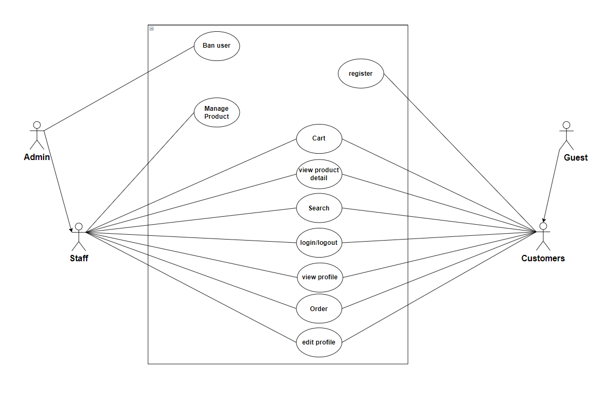

## 2.4. Activity diagrams

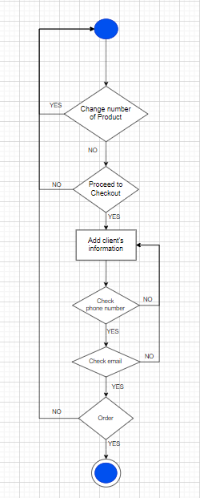

## Entity Relationship Diagram

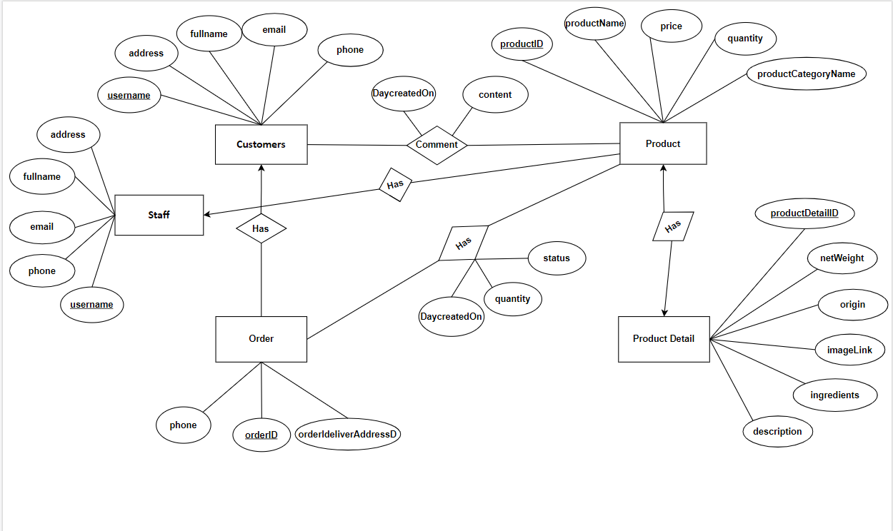

# Class diagram

s

1. **User Interface Model Design**

## 5.1 User interface model design

**5.1.1 Login Form**

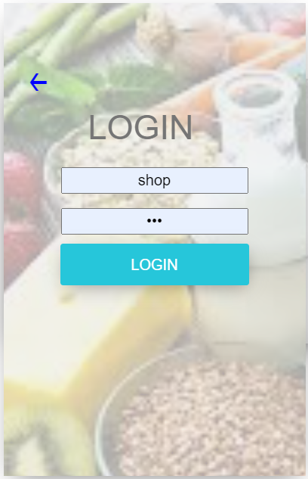

**5.1.2 RegisterGUI**

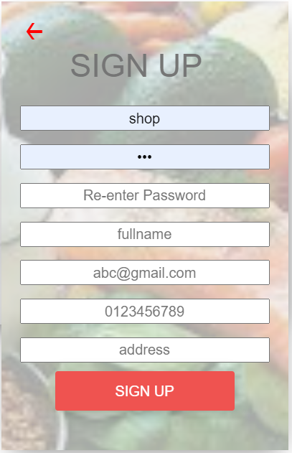

**5.1.3 Shop GUI**

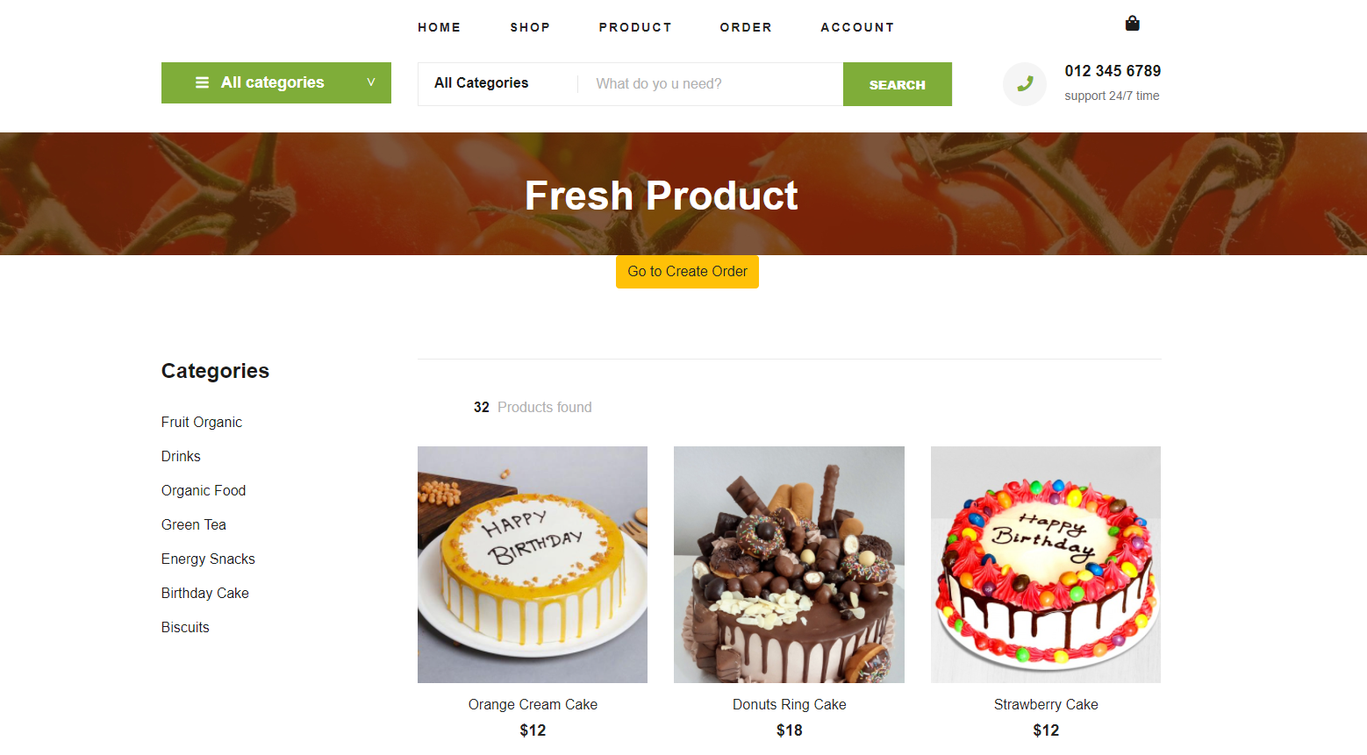

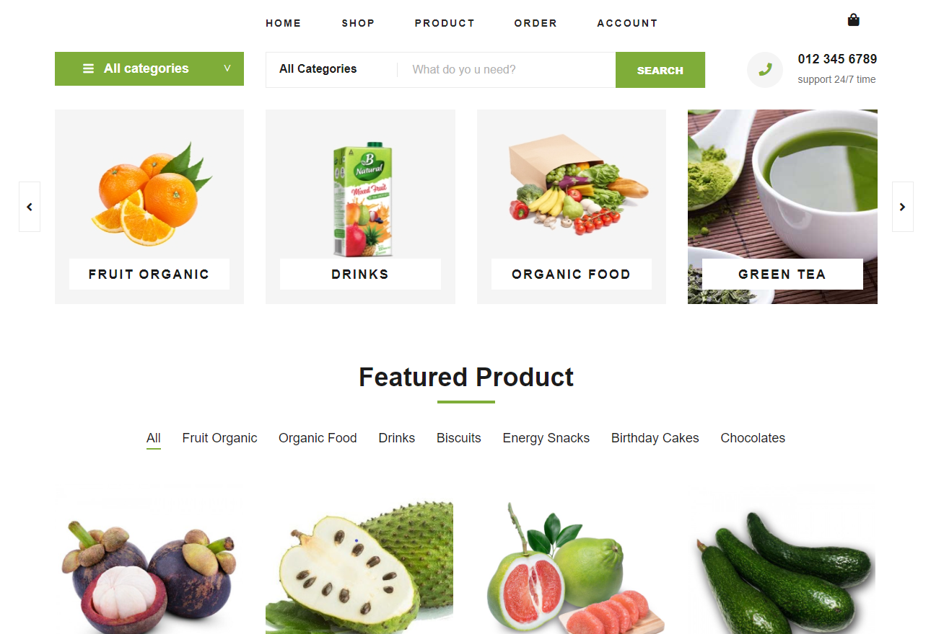

**5.1.4 Add Product**

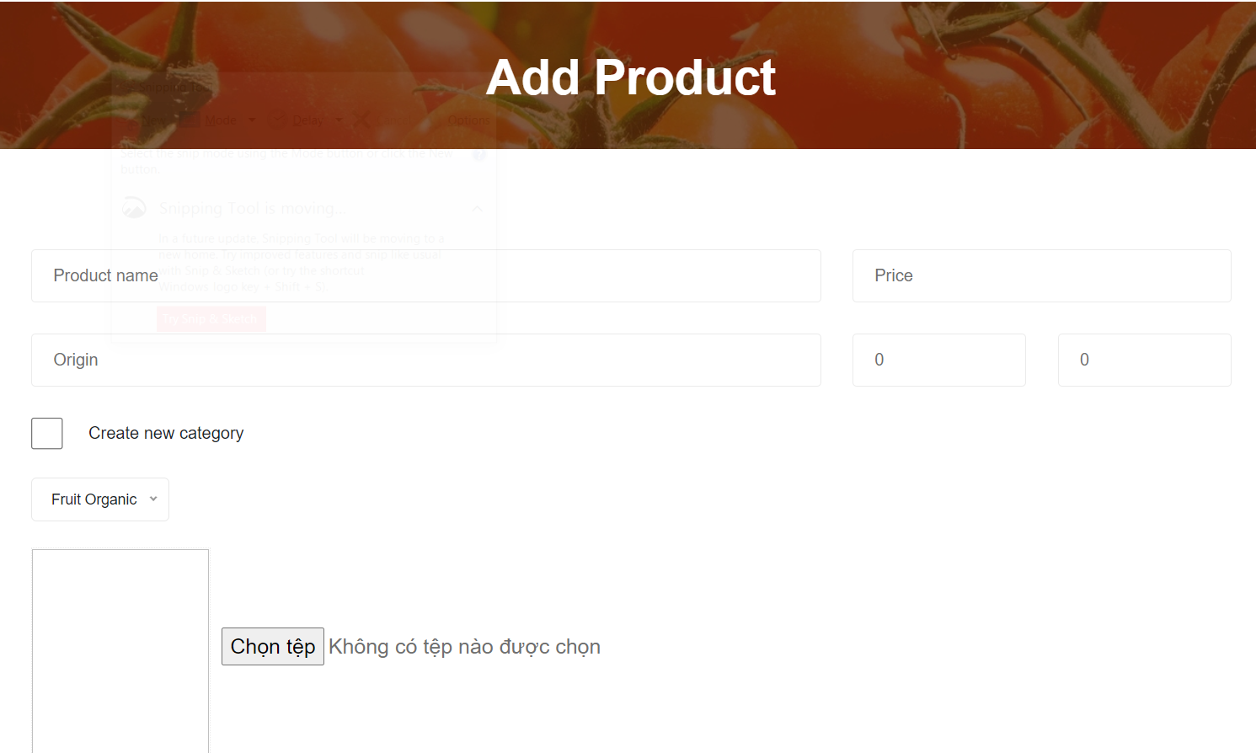

**5.1.5 Edit Product**

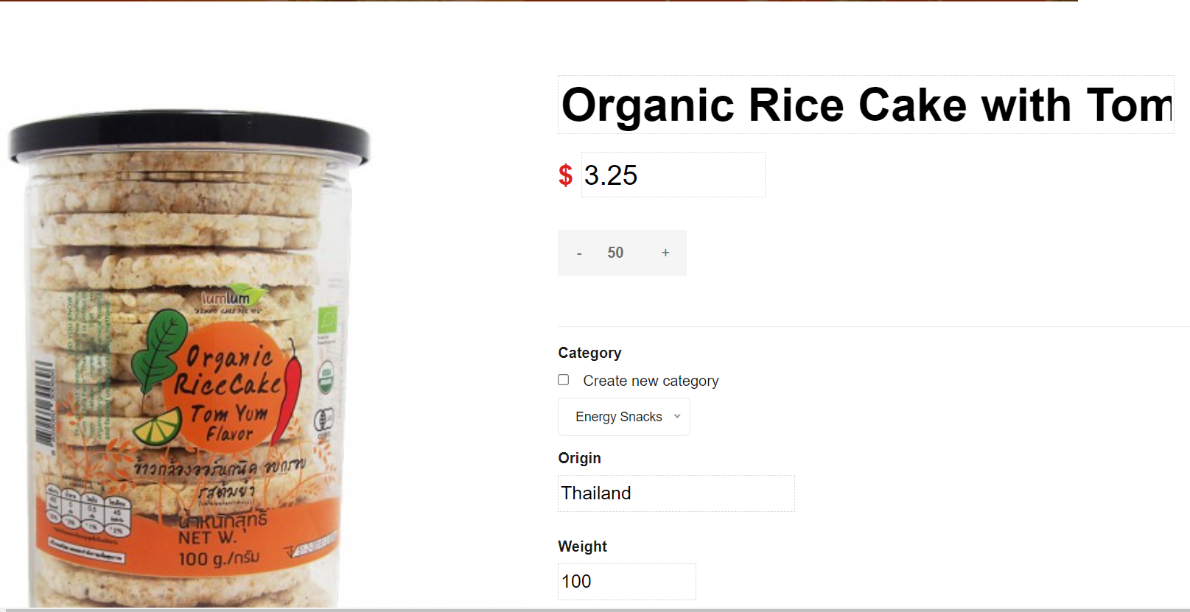

**5.1.6 Edit Profile**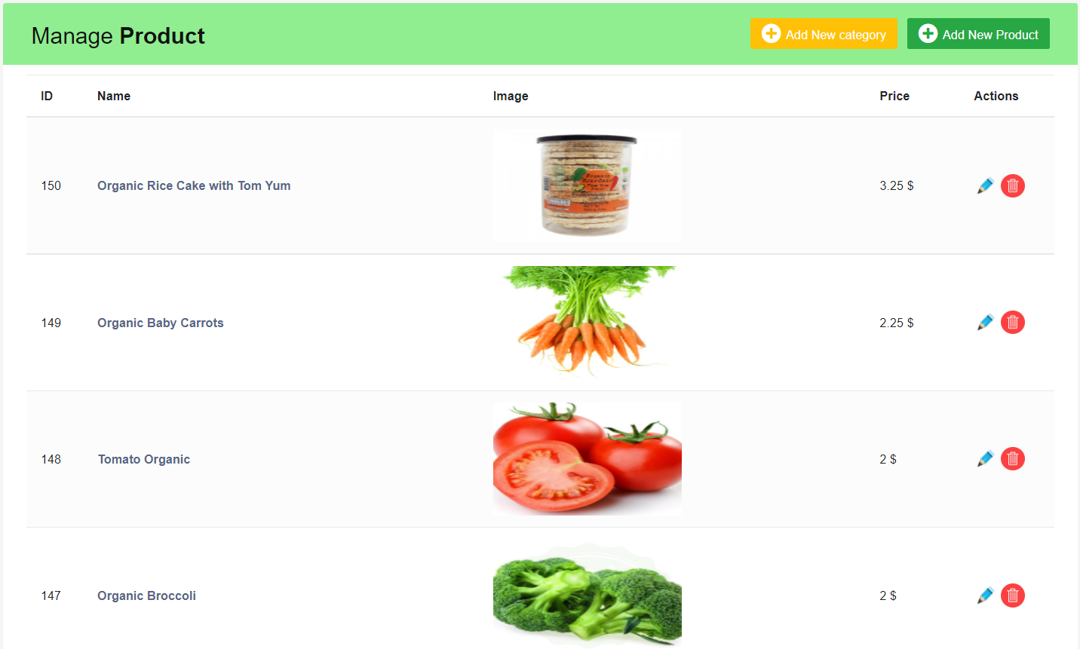

**5.1.7 Manage Order**

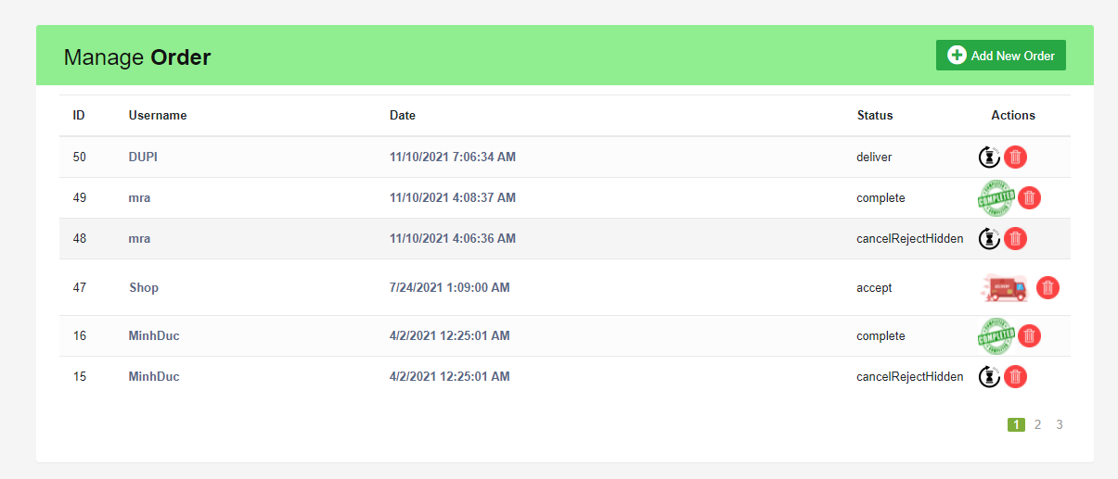

**5.1.8 ProfileUser**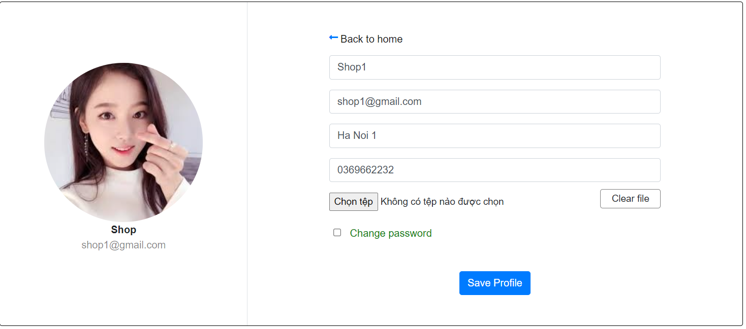

**5.2 Interface Flow Diagrams**

